**Lab 4**

**Name:** Etcherla Sai Manoj **Mis. No:** 112015044 **Branch:** CSE

**Question1:**

**Code:**

#include<iostream>

using namespace std;

class Sample

{

int num;

public:

void getvalue(){

cout << "Enter a number : ";

cin >> num;

}

void operator++(){

num = ++num;

}

void operator--(){

num = --num;

}

void display(){

cout << num;

}

};

int main(){

Sample s1;

s1.getvalue();

++s1;

cout << "Incremented number : ";

s1.display();

--s1;

cout << "\nDecremented number : ";

s1.display();

return 0;

}

**Input & Output:**

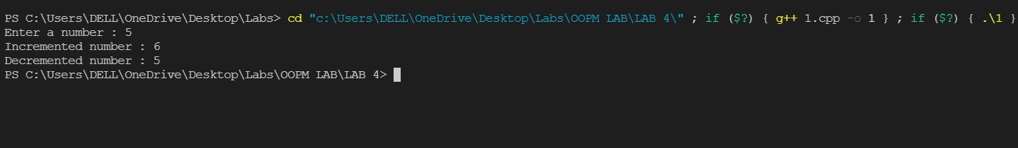

**Question2:**

**Code:**

#include<iostream>

using namespace std;

class Student

{

int marks;

public:

Student(){

marks = 0;

}

Student(int m){

marks = m;

}

friend bool operator==(Student &s1, Student &s2);

void display(){

cout << marks;

}

};

bool operator==(Student &s1, Student &s2){

return(s1.marks == s2.marks);

}

int main(){

Student s1(98);

Student s2(98);

cout << "Marks of Student 1 : ";

s1.display();

cout << "\nMarks of Student 1 : ";

s2.display();

if(s1 == s2){

cout << "\nBoth students marks are equal";

}

else{

cout << "\nBoth students marks are not equal";

}

return 0;

}

**Input & Output:**

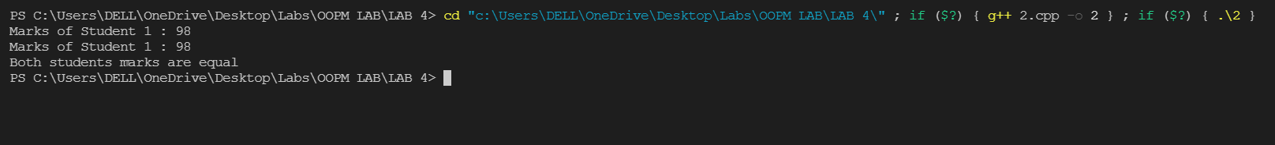

**Question3:**

**Code:**

#include<iostream>

using namespace std;

class Sample

{

int num1, num2;

public:

void getvalue(){

cout << "Enter a number : ";

cin >> num1;

}

Sample operator+(Sample &c){

Sample diff;

diff.num2 = num1 - c.num1;

return diff;

}

void display(){

cout << "The differnece of numbers : " << num2;

}

};

int main(){

Sample s1, s2, s3;

s1.getvalue();

s2.getvalue();

s3 = s1 + s2;

s3.display();

return 0;

}

**Input & Output:**

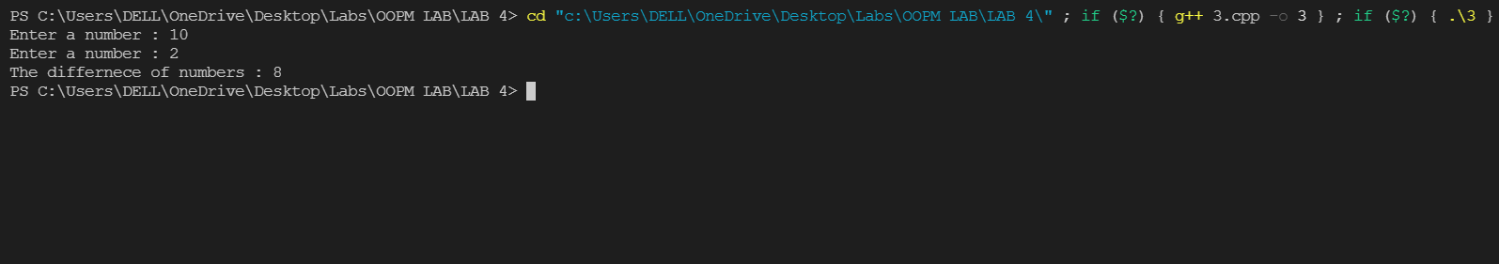

**Question4:**

**Code:**

#include<iostream>

using namespace std;

class Complex

{

int real, imag;

public:

Complex(){

real = 0, imag = 0;

}

void getvalue(){

cout << "Real part : ";

cin >> real;

cout << "Imaginary part : ";

cin >> imag;

}

friend Complex operator+(Complex c1, Complex c2);

void display(){

cout << real << " + " << imag << "i" << endl;

}

};

Complex operator+(Complex c1, Complex c2)

{

Complex c;

c.real = c1.real + c2.real;

c.imag = c1.imag + c2.imag;

return c;

}

int main(){

Complex c1, c2, c3;

cout << "Enter complex number 1\n";

c1.getvalue();

cout << "Enter complex number 2\n";

c2.getvalue();

c3 = c1 + c2;

cout << "Complex number 1 : ";

c1.display();

cout << "Complex number 2 : ";

c2.display();

cout << "The sum of complex numbers is : ";

c3.display();

return 0;

}

**Input & Output:**

